Software Requirements Specification
Version 3

Auto Ship
Client: Hassan Akram

Team 4
Member Name | Primary Responsibility
Muhammad Zunair | Management, Backend and Modal
Ruhaib ul Hassan | Backend, modal, SRS corrections and modifications.
Taimoor Zahid | Test cases.
Muhammad Usama Iftkhar | User Interface, Map functionality, Test cases
Saba Ali | IV&V
Basit Adnan | User Interface.

Table of Contents
Table of Contents ii
Revision History iii
1. Introduction 1
1.1 Product 1
1.2 Scope 1
1.3 Business Goals 1
1.4 Document Conventions 1
1.5 References 1
2. Overall Description 2
2.1 Product Features 2
2.2 User Classes and Characteristics 2
2.3 Operating Environment 2
2.4 Design and Implementation Constraints 2
2.5 Assumptions and Dependencies 2
3. Functional Requirements 3
3.1 Login 3
3.2 Import Orders 4
3.3 Update Order Status 5
3.4 Create User 6
3.5 Create Tags 7
3.6 Search an Order 8
3.7 Forget Password 9
3.8 Generate Graphs 10
3.9 Show Route 11
3.10 Reset Password 12
3.11 View all orders 13
3.12 Edit Profile 14
3.13 View Package 15
3.14 Delete User 16
4. Nonfunctional Requirements 17
4.1 Performance Requirements 17
4.2 Security Requirements 17
5. Other Requirements 17
Appendix A: Glossary 18
Appendix B: Analysis Models 18
Appendix C: Design Models 18
Appendix D: Screenshots 18
Appendix E: Test Cases 18
Appendix F: IV & V Report 19
Appendix G: Risk Report 20
Appendix H: Activity Timesheet 21
Appendix I: Updated Project Plan 22

Revision History

Name(s) | Date | Reason(s) For Change(s) | Version
Update introduction and description | 15/9/2016 | Client meeting more clear scope and requirements | 0.2
Use case revision | 22/9/2016 | And IV &V proposed changes in use cases | 0.4
Use case revision | 22/9/2016 | Project Manager recommendations on use cases | 1.0
Use case revision | 18/10/2016 | Minor changes because was not catering the functionalities as it can implement. | 1.1
GUI revision | 20/10/2016 | Conflict between use cases and GUI | 2.0
SRS corrections version 2.0 | 25/11/2016 | Reasons include:  - Revision history sorted in descending order.  - Stick figures not used in use-case diagram.  - Splitting user based use-case for better understanding.  - Primary keys in ER diagram not underlined.  - Recursive relation symbol missing in ER diagram.  - Splitting of DFD on in shorter snapshots.  - Incorrect origin stages in IV&V report.  - Time of defects is missing in IV&V report.  - Accumulated requirement engineering time.  - Project plan milestones and dependency of tasks missing. | 2.1
Test cases revisions | 30/11/16 | Modifications and corrections in test cases | 3.0

Introduction

Product
This product allows store sellers to automate their shipping process. It includes importing of data from stores (e.g. Amazon, Jet.com, eBay etc.), reporting for managers, pre-sorting, finally shipping of orders and Google maps for assisting in delivery.

Scope
This project will facilitate managers to maintain their business. Admin can create accounts for different type of users like shipping manager, packing manager and delivery person. Each user will have restricted access to functionalities. Admin can create report in the form of graphs to analyze business. He will not be able to save or delete reports and only static reports will be created on point and click. System will create unique tags for orders, printing of tag is not part of system. Data will be standardized so that our system can support it but it will be imported from other stores by using some API. Delivery person will select the region and map will show the route of delivery.
Project is divided into three phases and working application will be delivered in last week of November 2016.

Business Goals
Business goals of this product includes to solve the complexities faced by sellers of online shopping after an order has been placed. This includes picking procedure, packing procedure, and shipping.

Document Conventions
The document uses 11 font size with Arial font family for the description of points. Main headings are bold in Times font family with 18 font size and sub-headings are of 14 font size. Use case heading are using Verdana with 12 font size. Use of bullet points to mention important details. Bold user classes in section 2.2. Document uses formatting that is easy to read and helps to understand.

References
[1] http://www.amazon.com
[2] http://www.jet.com
[3] http://www.ebay.com
[4] http://www.channeladvisor.com

Overall Description

Product Features
This product includes multilevel user authorization which can be Admin, packing manager, shipping manager and delivery person with restricted access level to data.

- System shall be able to import orders from amazon, ebay and jet.com
- System shall manage inventory
- System shall be able to search and filter orders for packing and shipping purposes
- Analysis graphs shall be provided by the system
- System shall be able to auto-generate tags for orders
- Google maps shall be provided by the system to facilitate shipping
- System shall be able to sort orders on product and region basis

User Classes and Characteristics
Admin have complete access of the system which includes create other users account, import orders, create graphs for analysis and all other task that normal user can do.
Shipping Manager Select orders for shipping.
Packing Manager Place tags and do Pre-sorting
Delivery person Able to find route to the customer address.

Operating Environment
- Any computer with support of latest Google chrome and Firefox.
- Minimum 1MB internet connection

Design and Implementation Constraints
- Use of PHP for back-end development.
- Limited time window of three months.
- Use of MySQL database.
- Highly secured application.

Assumptions and Dependencies
- This project has a dependency of the Api used for importing data from amazon, e-bay and jet.com
- End users have technical knowledge of computers and browsers.
- Major Functional requirements will not be changed by the client.
- User Interface templates will be used. (like bootstrap)
- Use of client proposed architecture and tools

Functional Re-quirements

Login
Identifier |  | UC-1
Purpose |  | Get access to profile for doing job
Priority |  | High
Actors |  | Admin, Shipping Manager, Package Manager, Delivery person
Pre-conditions |  | User has an account.
Post-conditions |  | User has successfully logged in.
Typical Course of Action
S# | Actor Action |  | System Response
1 |  |  | Asks for user id.
2 | Enter Email id.
3 |  |  | Asks for password.
4 | Enter password.
5 | Click on login button.
6 |  |  | Log in to profile.
Alternate Course of Action
S# | Actor Action |  | System Response
11 |  |  | Prompt message (“Your id or password is incorrect.”)
 |  |  | Go to step 1.

Import Orders
Identifier |  | UC-2
Purpose |  | Import orders for shipment.
Priority |  | High
Actors |  | Admin
Pre-conditions |  | Orders are available
Post-conditions |  | Orders are added in record.
Typical Course of Action
S# | Actor Action |  | System Response
1 | Request to import orders.
2 |  |  | Get orders from channeladvisor.
3 |  |  | Standardize orders according to pre-define rules.
4 |  |  | Display new orders.
5 | Click save button.
6 |  |  | Orders are saved.
Alternate Course of Action 1
S# | Actor Action |  | System Response
5 |  |  | Display Message “No orders to display”

Update Order Status
Identifier |  | UC-3
Purpose |  | To familiarize with the shipping progress whether order is delivered or not.
Priority |  | Medium
Actors |  | Delivery person, shipping manager
Pre-conditions |  | Order is available.
Post-conditions |  | Status is updated.
Typical Course of Action
S# | Actor Action |  | System Response
1 |  |  | Show order details including list of available statuses.
2 | Select a status.
3 | Click on save button.
4 |  |  | Update status.
Alternate Course of Action
S# | Actor Action |  | System Response

Create user

Identifier |  | UC-4
Purpose |  | Create different type of user to make shipment process easy.
Priority |  | High
Actors |  | Admin
Pre-condition(s) |  | Admin must be logged in.
Post-condition(s) |  | The User has been Created.
Typical Course of Action
S# | Actor Action |  | System Response
1 | The Admin selects the Create User Option.
2 |  |  | Prompts the Admin to provide the personal information.
3 | Enters name.
4 | Enters CNIC no.
5 | Enters email id.
6 | Enters password.
7 | Enters Confirmation password.
8 | Enters contact no.
9 | Enters date of birth.
10 | Select user role.
11 | Click save button.
12 |  |  | Creates the Account.
Alternate Course of Action 1
S# | Actor Action |  | System Response
13 |  |  | Error “Some field is empty”
Go to step 3.

Create tags

Identifier |  | UC-5
Purpose |  | Create unique and understandable tags to facilitate shipping.
Priority |  | Medium
Actors |  | Packing manager
Pre-condition(s) |  | Orders must exist in the local database.
Post-condition(s) |  | Tags are assigned to Orders.
Typical Course of Action
S# | Actor Action |  | System Response
1 |  |  | Display list of orders that have no tags currently assigned to them.
2 | Select orders to create tags.
 | Click generate tag button.
3 |  |  | Generate tags on the basis of country, region, date, order name/customer name and order id.
4 |  |  | Associates the tag with the order in the list.
Alternate Course of Action 1 (If the list is empty)
S# | Actor Action |  | System Response
2 |  |  | Message “No un-tagged orders found”

Search orders

Identifier |  | UC-6
Purpose |  | Search Orders
Summary |  | This use case describes how a user searches for orders using filters for advance search facility
Priority |  | Medium
Actors |  | Admin, Shipping Manager, Packing Manager, Delivery Person
Pre-condition(s) |  | User must be logged in.
Post-condition(s) |  | A list containing search results
Typical Course of Action
S# | Actor Action |  | System Response
1 | The Manager selects the search option.
2 |  |  | Prompts the user to search for the project based on order id, order name, region, status and price.
3 | Manager enters information.
4 |  |  | Displays the search result
Alternate Course of Action 1 (If no order fulfills the criteria)
S# | Actor Action |  | System Response
4 |  |  | Message “No orders found”
Go to step 3.

Forget Password
Identifier |  | UC-7
Purpose |  | To get access to account in case of forgetting password
Priority |  | Medium
Actors |  | Admin, Shipping Manager, Packing Manager, Delivery Person
Pre-conditions |  | User Account has already been created
Post-conditions |  | Password is changed and account accessible
Typical Course of Action
S# | Actor Action |  | System Response
1 | Enters E-mail id.
2 | Selects forget password option.
3 |  |  | Confirms E-mail id.
4 |  |  | Sends verification email to Email address.
5 | Opens his Email inbox.
6 | Clicks the change password link.
7 |  |  | Asks for new password
8 | Enters the new password.
9 |  |  | Ask for password confirmation.
10 | Enter confirmation password
12 |  |  | Displays password change successfully message.
13 |  |  | Redirects to profile page.
Alternate Course of Action 1
S# | Actor Action |  | System Response
3 |  |  | Email not confirmed.
3.1 |  |  | Asks for email again. Go to step 1.

Generate graphs

Identifier |  | UC-8
Purpose |  | Generate graph reports to analyze sales.
Priority |  | Medium
Actors |  | Admin
Pre-conditions |  | All the data has been imported in the system.
Post-conditions |  | Required graph or chart displayed.
Typical Course of Action
S# | Actor Action |  | System Response
1 | Selects generate chart option.
2 | Selects the required data.
4 |  |  | Displays chart types.
5 | Selects a type.
6 |  |  | Displays the chart.
Alternate Course of Action 1
S# | Actor Action |  | System Response
 |  |  | Display Message “No data found”

Show route

Identifier |  | UC-9
Purpose |  | To display all the locations for delivery in a region.
Priority |  | High
Actors |  | Delivery Person
Pre-conditions |  | All the deliveries are stored in the system
Post-conditions |  | Deliverables delivered at the correct place
Typical Course of Action
S# | Actor Action |  | System Response
1 | Search a region.
2 |  |  | Gets all the deliveries for the region.
3 |  |  | Locate the deliveries on map.
4 |  |  | Computes the shortest path to all deliveries.
5 |  |  | Displays the map with the route.
6 | Selects navigation option.
7 |  |  | Navigates user through GPS.
Alternate Course of Action 1
S# | Actor Action |  | System Response
5 |  |  | Display message “no deliveries in specified region”
5.1 |  |  | Redirect to step 1.

Password reset

Identifier |  | UC-10
Purpose |  | Reset password
Priority |  | Medium.
Actors |  | Admin, Shipping Manager, Packing Manager, Delivery Person
Pre-conditions |  | User is logged in with his/her account.
Post-conditions |  | Password is reset.
Typical Course of Action
S# | Actor Action |  | System Response
1 | Request for password reset.
2 |  |  | Redirect the user to password reset page.
3 | Fills the current password field.
4 | Fills the new password field.
5 | Confirms the new password by re-entering the password.
6 | Clicks the save button.
7 |  |  | Responds with the “password changed successfully” message.
Alternate Course of Action 1
S# | Actor Action |  | System Response
7 |  |  | Alerts with error message that required fields are empty.
 |  |  | Go to step 3

View all orders

Identifier |  | UC-11
Purpose |  | To view the orders present.
Priority |  | Medium
Actors |  | Admin, Shipping Manager, Packing Manager, Delivery Person
Pre-conditions |  | Orders are allowed to be viewed.
Post-conditions |  | Order list is shown.
Typical Course of Action
S# | Actor Action |  | System Response
1 | Select all order option.
2 |  |  | Show order details.
Alternate Course of Action
S# | Actor Action |  | System Response
2 |  |  | Returns the message that no rows to be shown/ no rows found.

Edit profile
Identifier |  | UC-12
Purpose |  | Edit Profile
Priority |  | Medium
Actors |  | Admin, Shipping Manager, Packing Manager, Delivery Person
Pre-conditions |  | User already exists
Post-conditions |  | Edited Profile.
Typical Course of Action
S# | Actor Action |  | System Response
1 | Request to edit the profile.
2 |  |  | Display editable profile.
3 | Edit the name.
4 | Edit CNIC no.
5 | Edit email id.
6 | Edit contact no.
7 | Edit date of birth.
8 | Click save button.
9 |  |  | Save the changes.
10 |  |  | Redirects to profile page.
Alternate Course of Action 1
S# | Actor Action |  | System Response
9 |  |  | Alerts error “Required field is empty”

View Package by region
Identifier |  | UC-13
Purpose |  | View Package by Region
Priority |  | Medium
Actors |  | Delivery Person
Pre-conditions |  | Packages are available
Post-conditions |  | Packages list is displayed.
Typical Course of Action
S# | Actor Action |  | System Response
1 |  |  | Prompts to select region
2 | Inputs Region.
3 |  |  | Returns region wise sorted Package list
Alternate Course of Action
S# | Actor Action |  | System Response
3 |  |  | Display "No deliveries in specified region".
3.1 |  |  | Redirects to step 1

Delete user

Identifier |  | UC-14
Purpose |  | Delete the user
Priority |  | Low
Actors |  | Admin
Pre-conditions |  | User exists
Post-conditions |  | User is removed.
Typical Course of Action
S# | Actor Action |  | System Response
1 | Opens the all employees page.
2 |  |  | Display delete option with every employee.
3 | Click the delete button of a particular employee.
4 |  |  | Deletes the user.
5 |  |  | Display updated employee list.
Alternate Course of Action
S# | Actor Action |  | System Response
4 |  |  | Display message "No other employee exist".

Nonfunctional Requirements

Performance Requirements
- Pre-sort the orders for analysis purposes on various conditions.
- Estimated time complexity should be linear to search an order.

Security Requirements
- Store passwords after hashing.
- Proper authorization of every user.
- One user should not be able to access other users’ data.
- Email authentication for password restoration.

Other Requirements

Appendix A: Glossary
<Define all the terms necessary to properly interpret the SRS, including acronyms and abbreviations. You may wish to build a separate glossary that spans multiple projects or the entire organization, and just include terms specific to a single project in each SRS.>

Appendix B: Analysis Models
CLASS DIAGRAM:

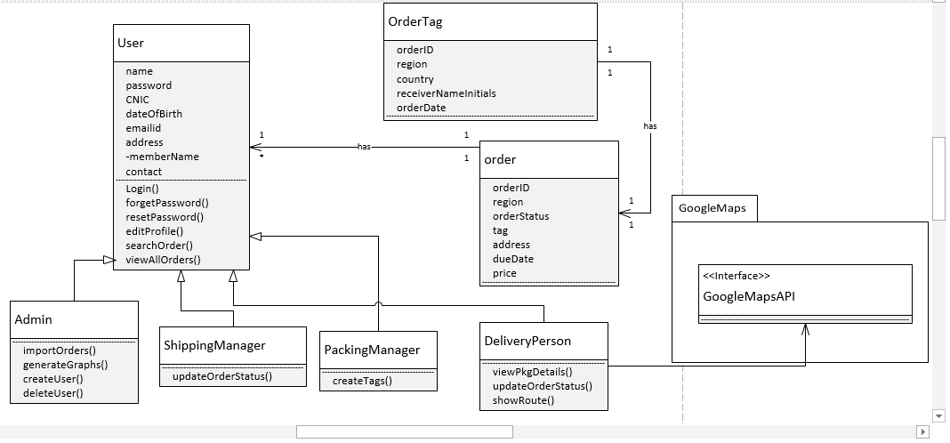

Data Flow Diagram

L0
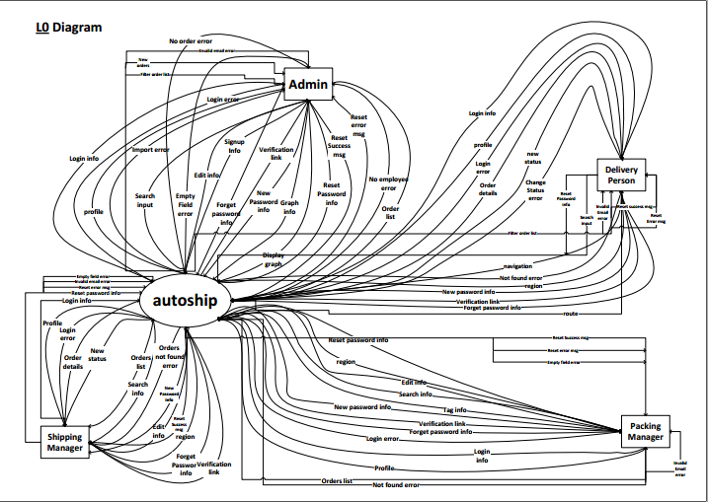

Level 1:

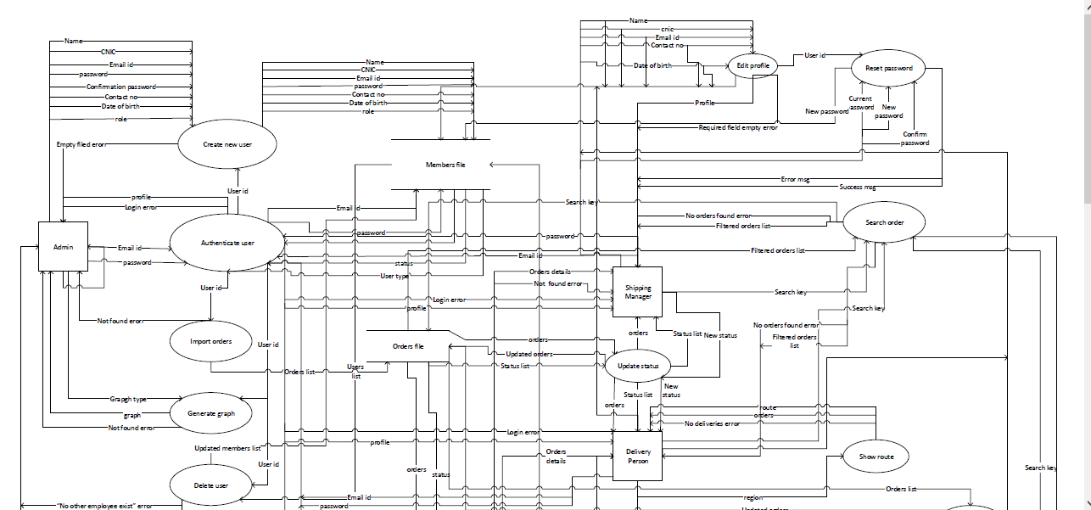

Level 1 (Continued…):
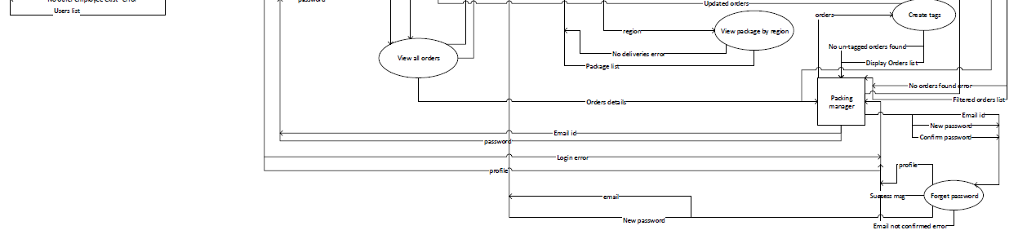
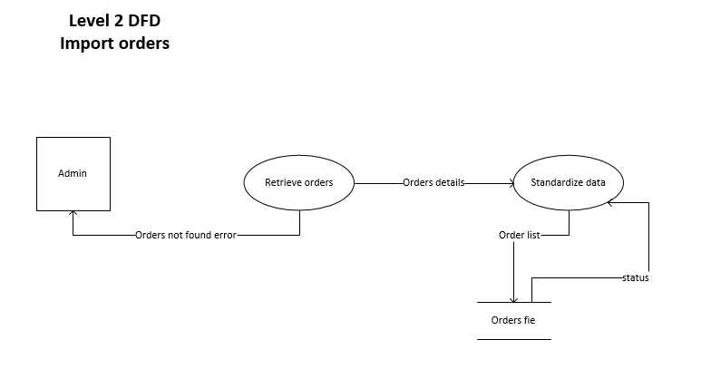
Level 2:

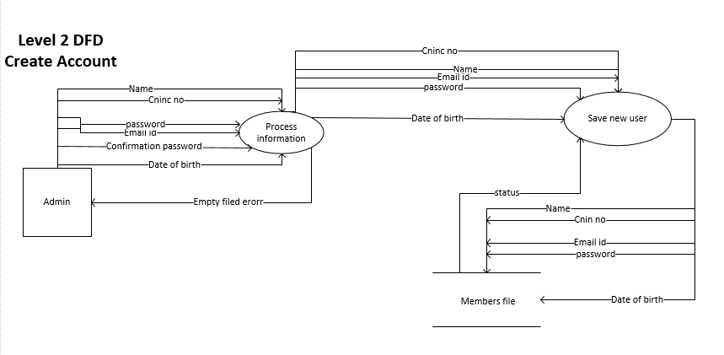
Level 2 (Continued..)

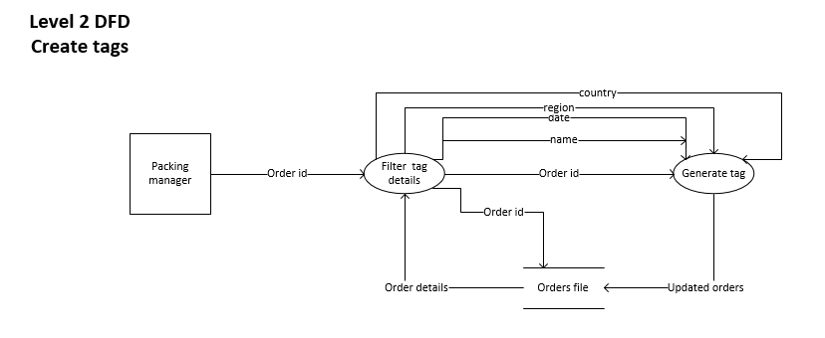
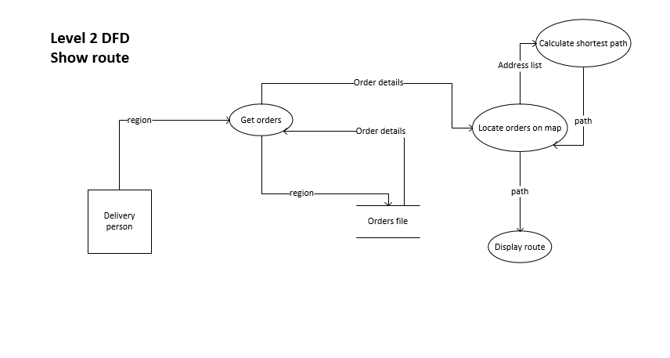
Use-Case Diagram:

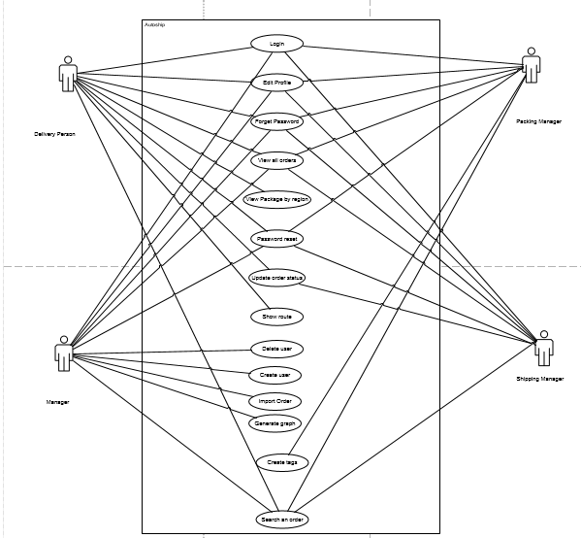
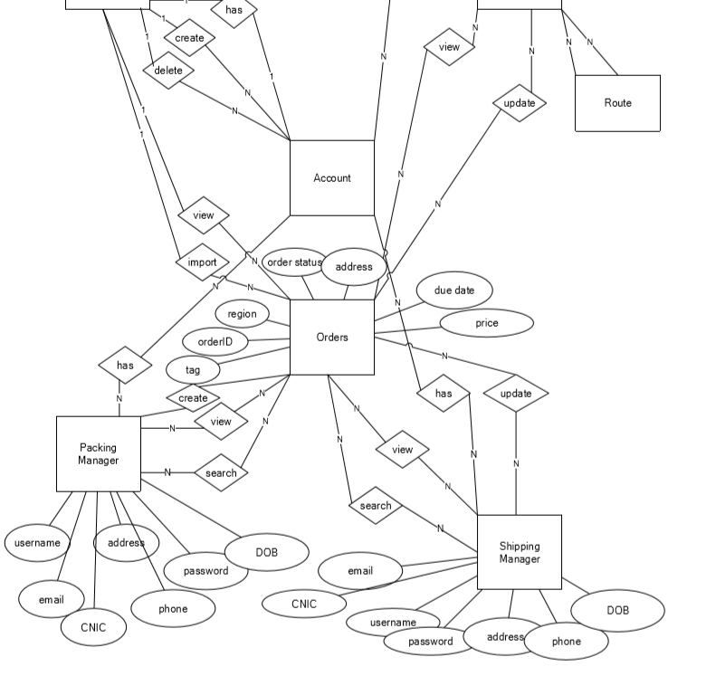
ER-Diagram:
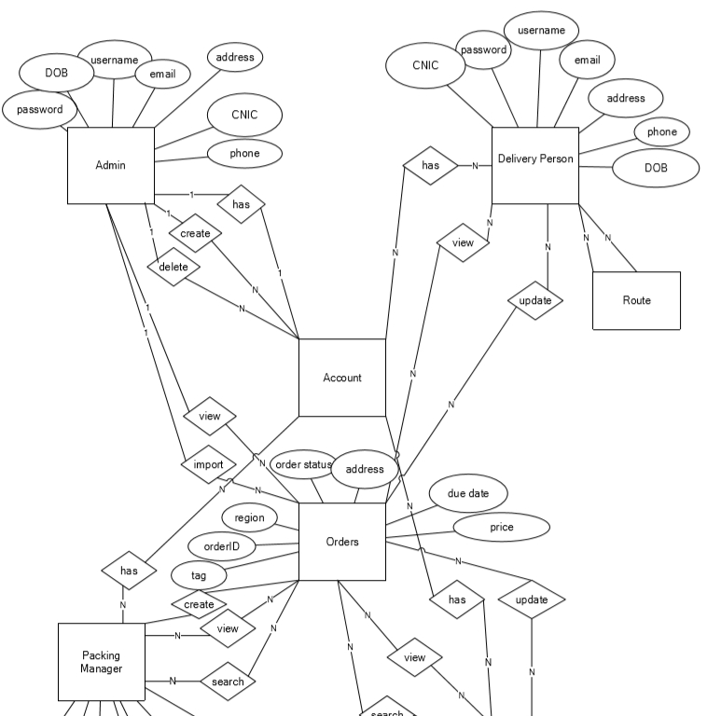

Appendix C: Design Models

Appendix D: Screenshots

Login

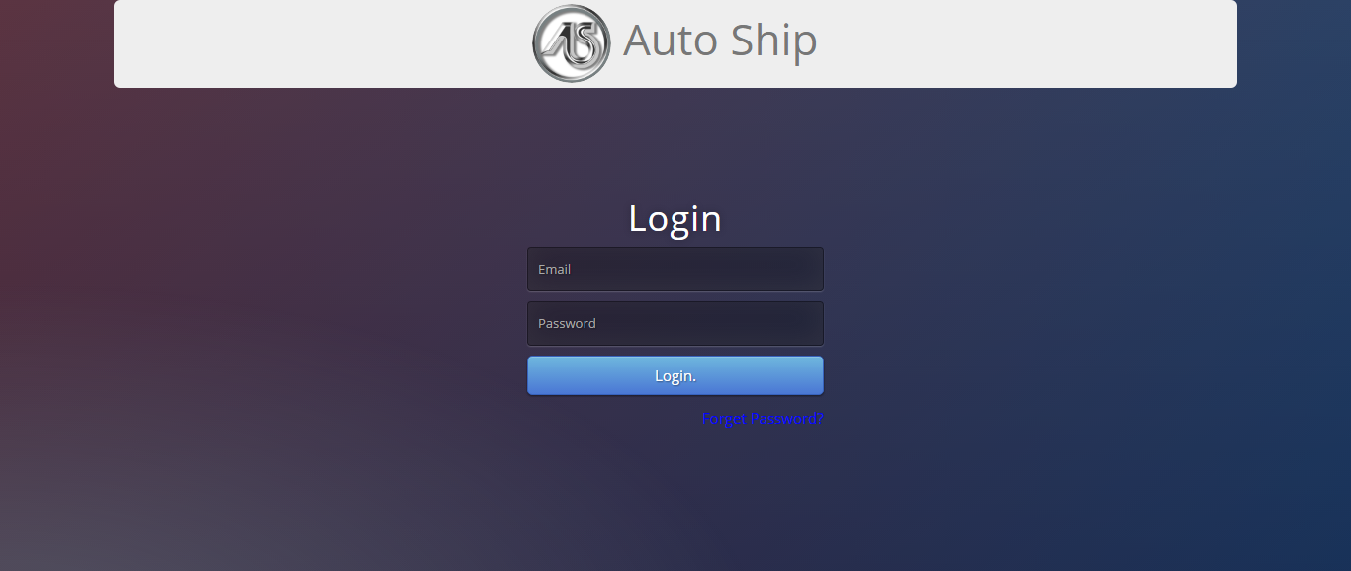

Login Error
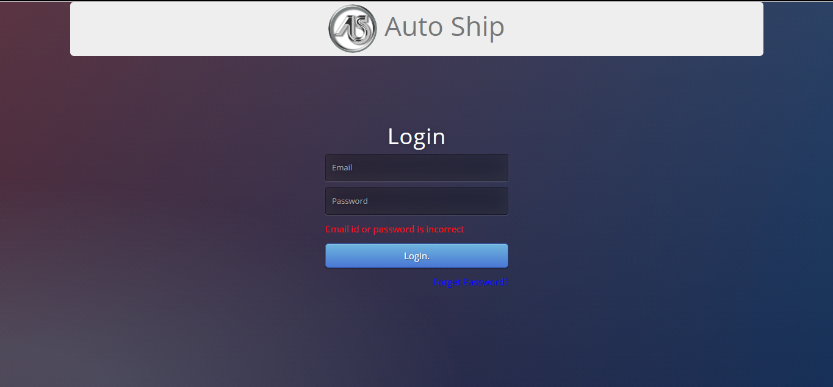

Manager
Profile:
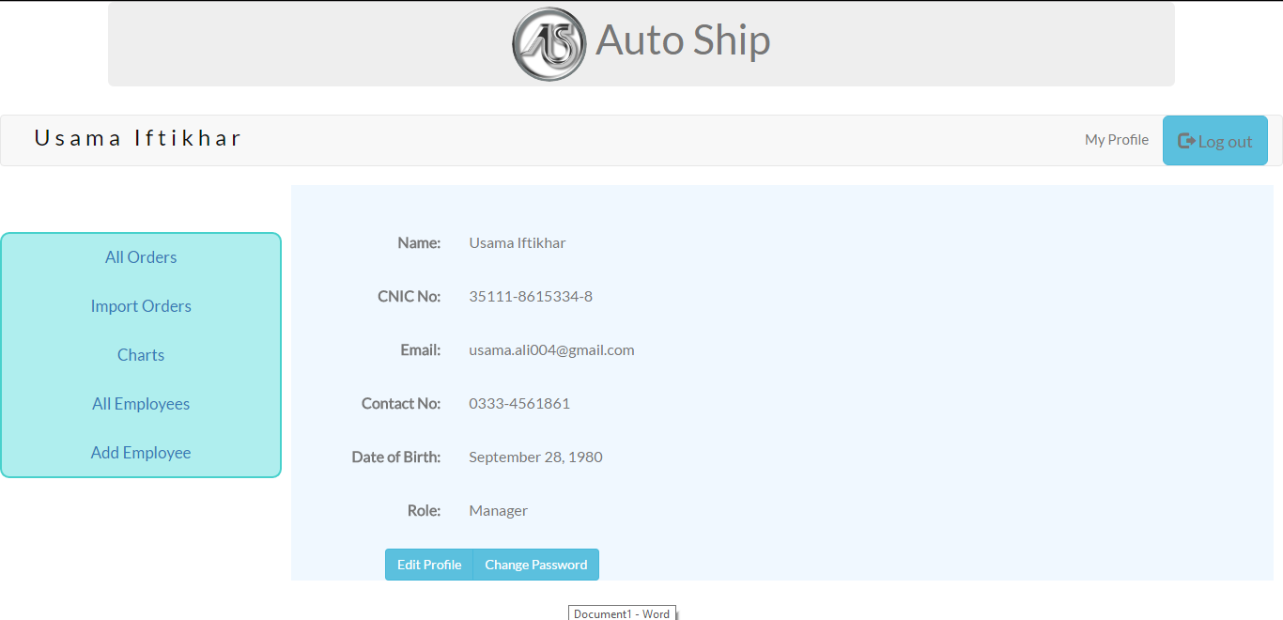

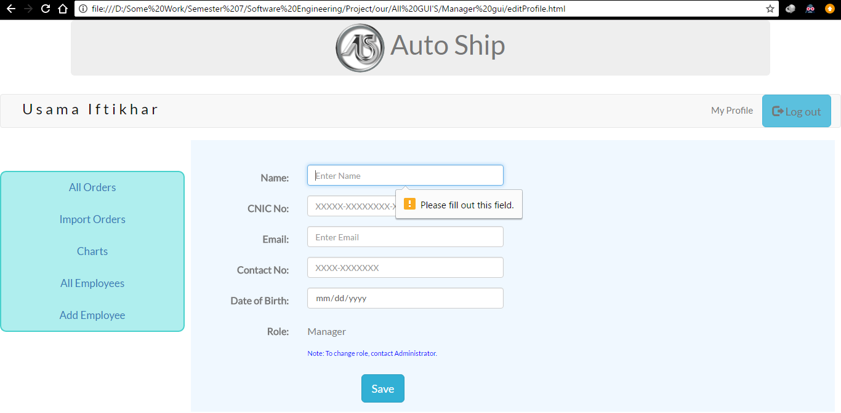
Edit Profile:

Change Password:
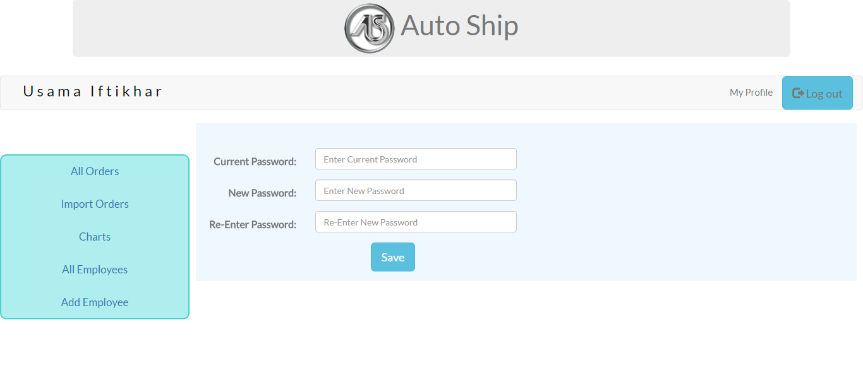

Change Password: Success
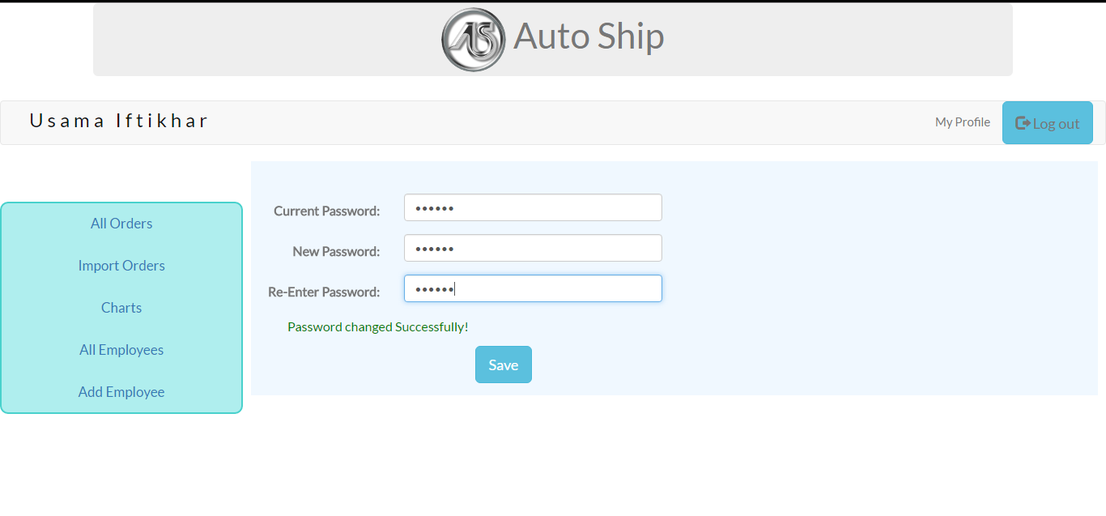

Change Password: Error
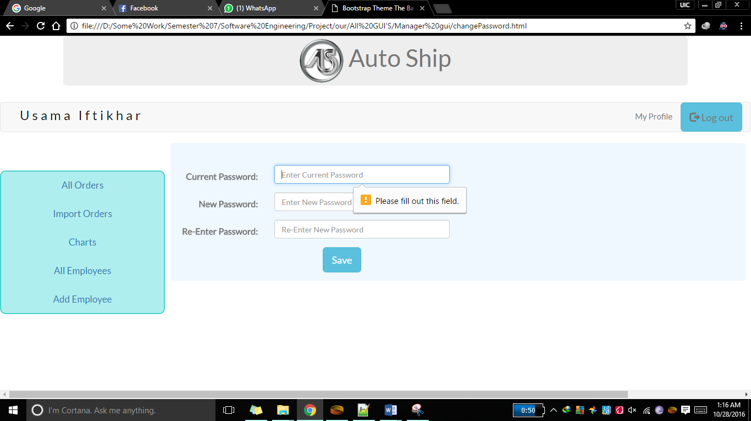

All Orders:
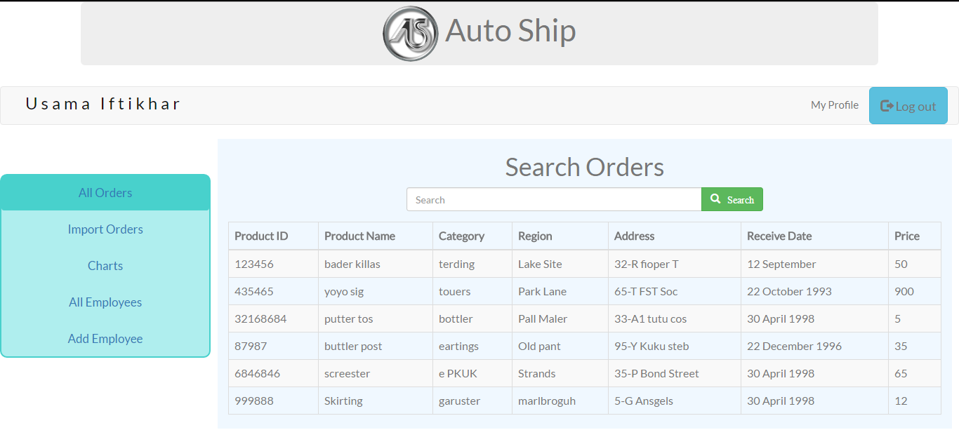
Import Orders:
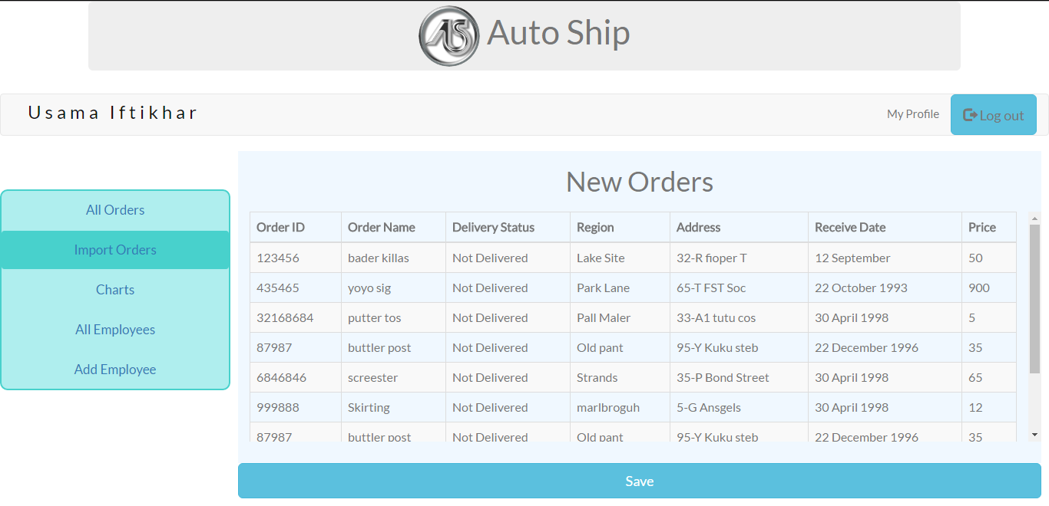

Import Order: Error
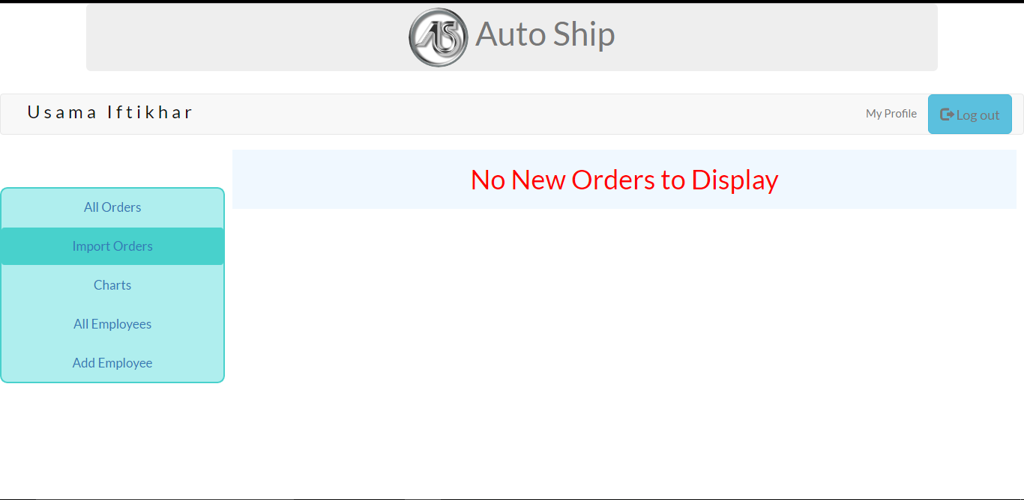

Charts:
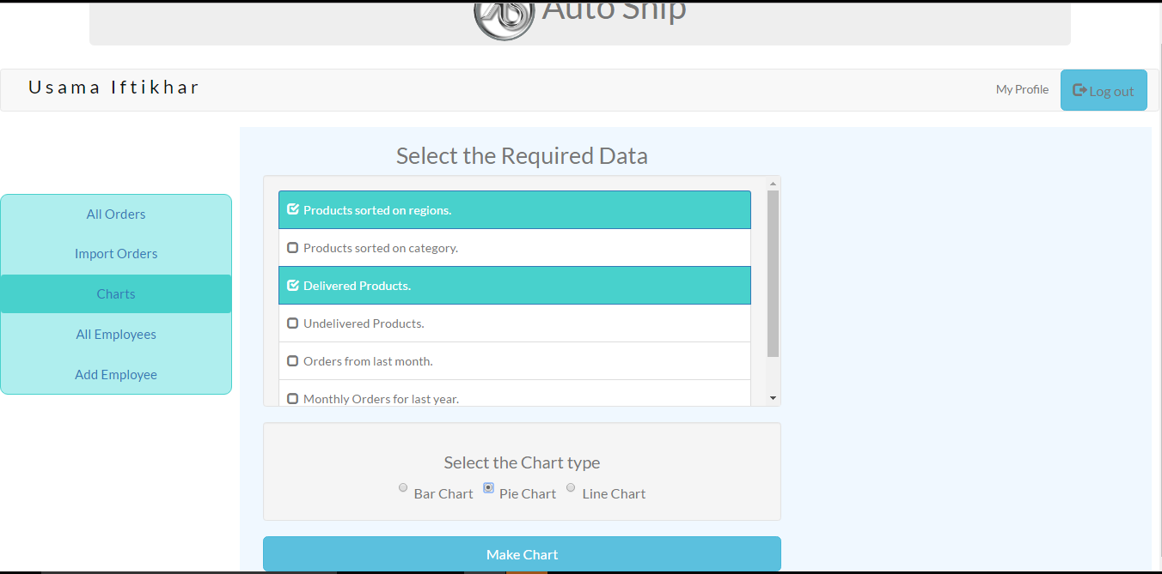

Chart Displayed:
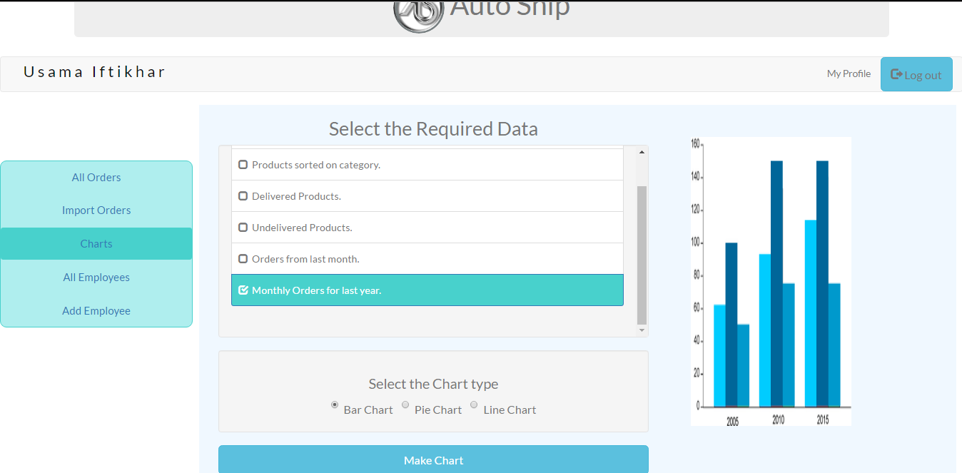
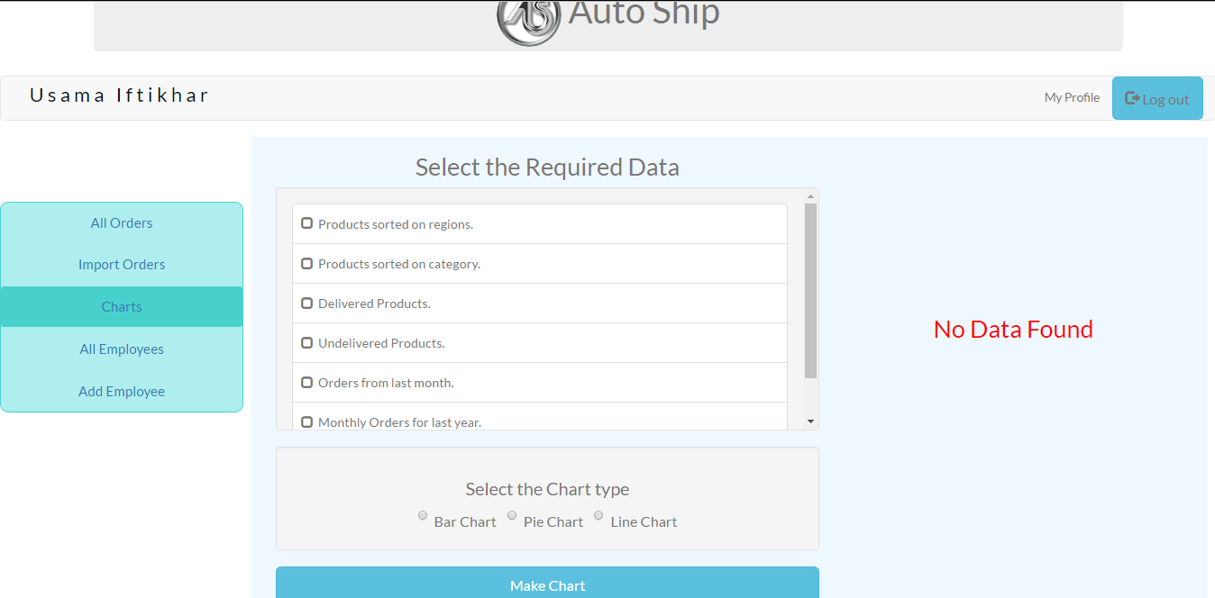

All Employees:
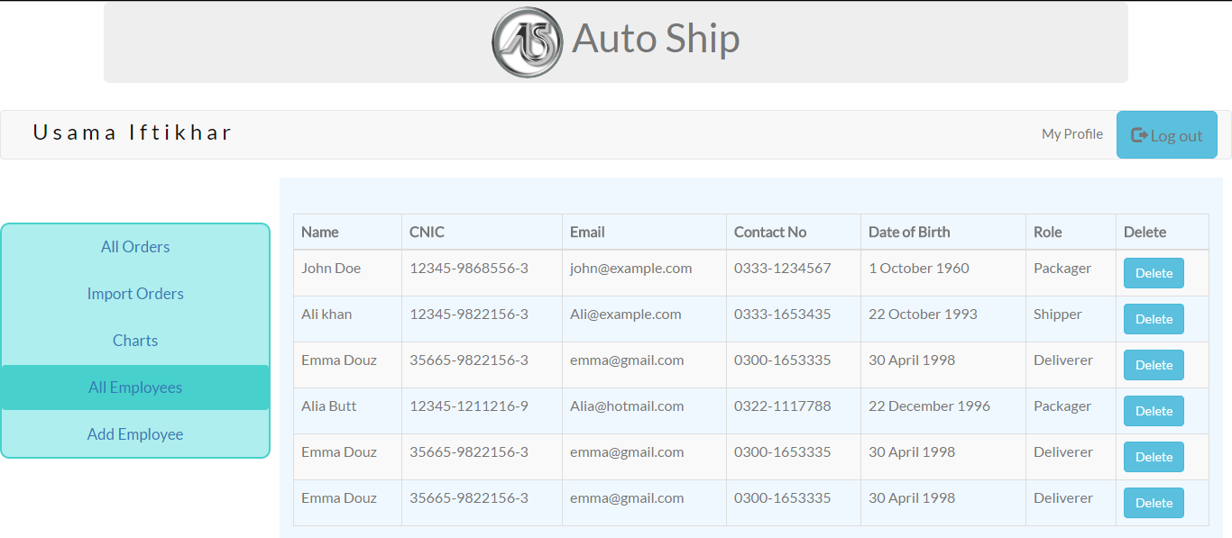

All Employees: Error
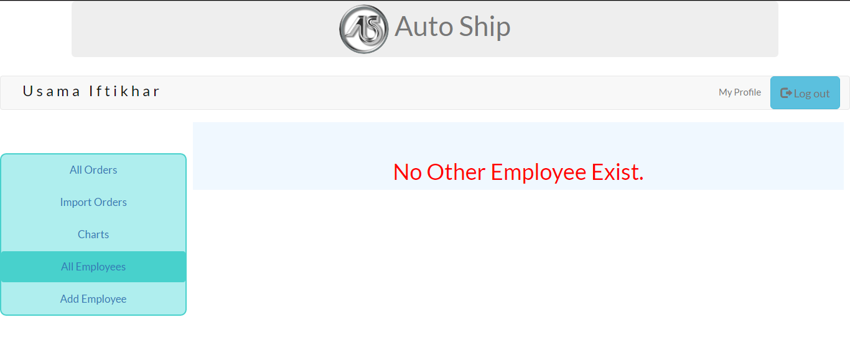
Add Employee: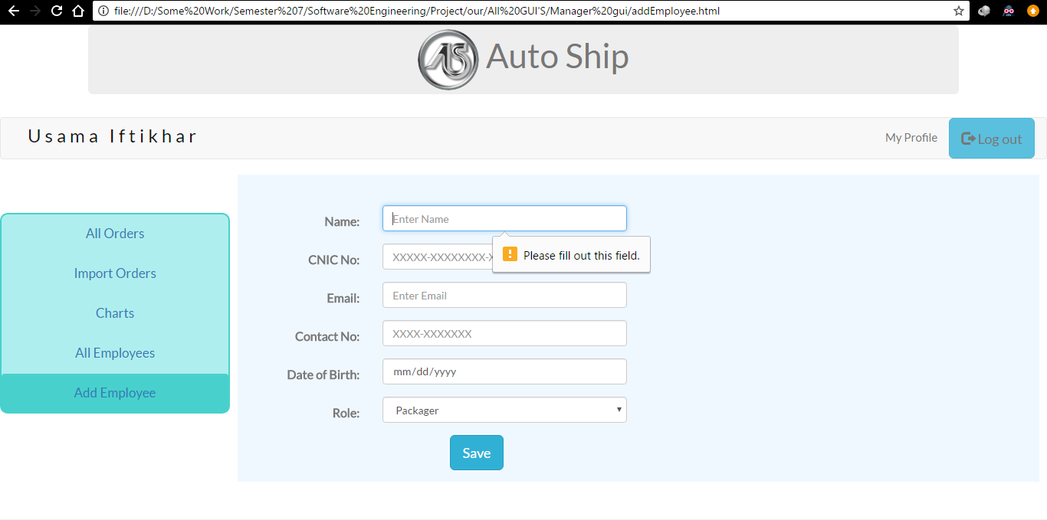

Delivery Person
All Orders:
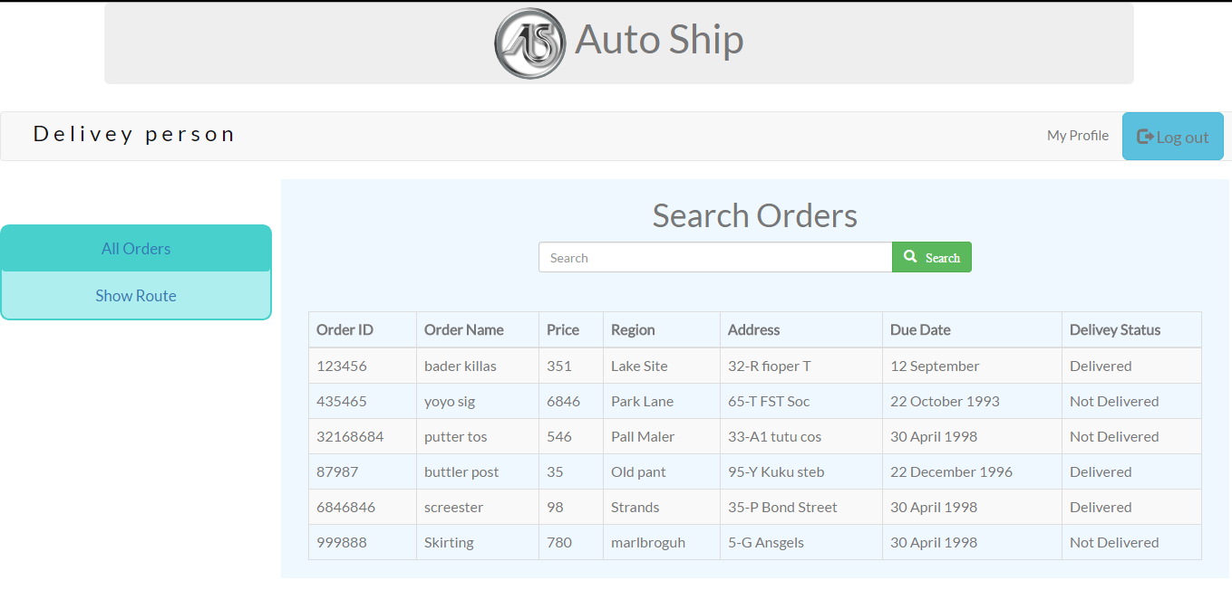

All Orders: Error
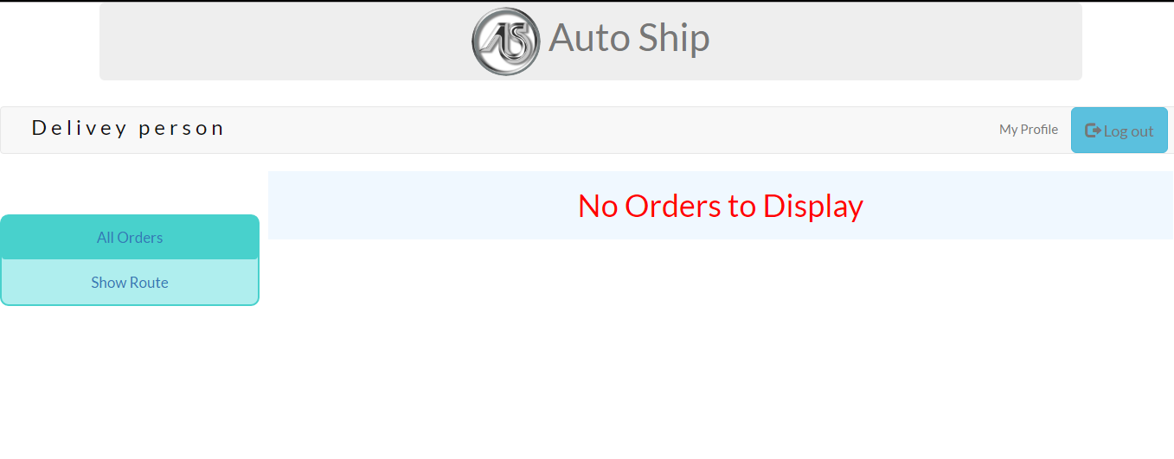

Show Route:
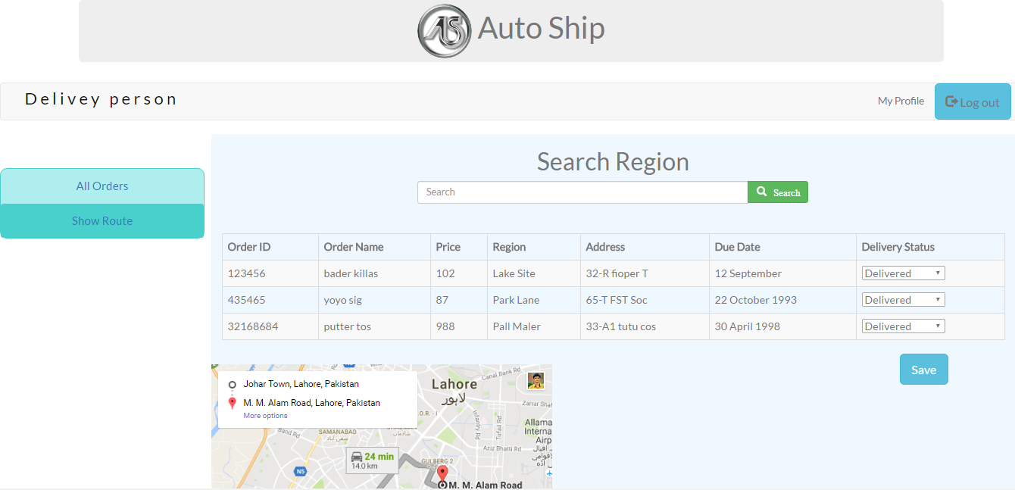

Show Route: Error
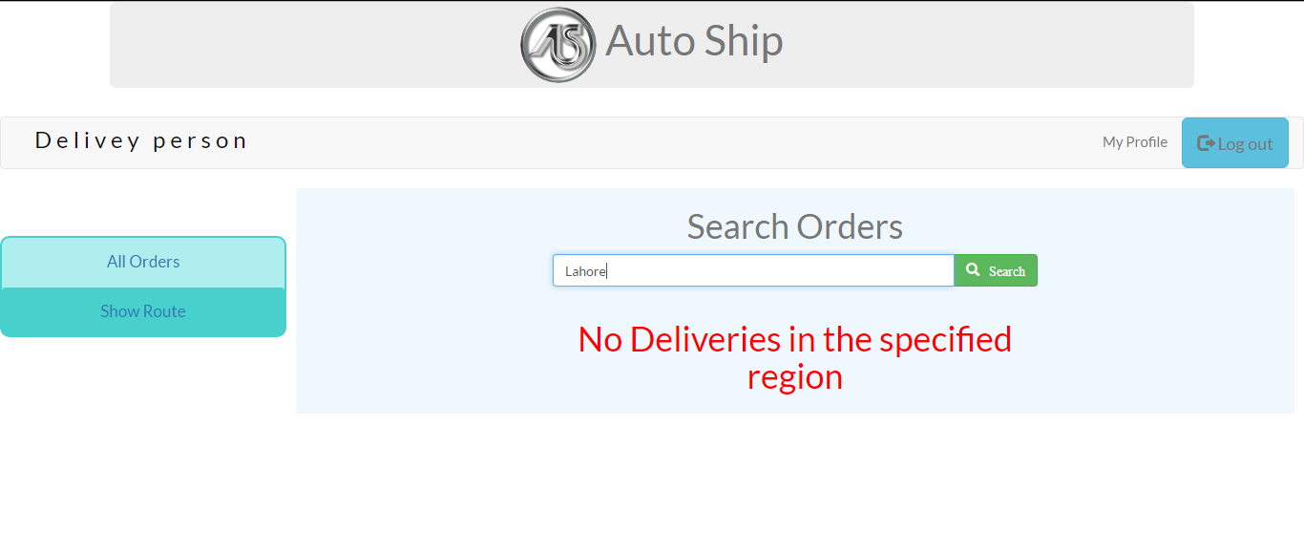

Package Manager
Generate Tags:
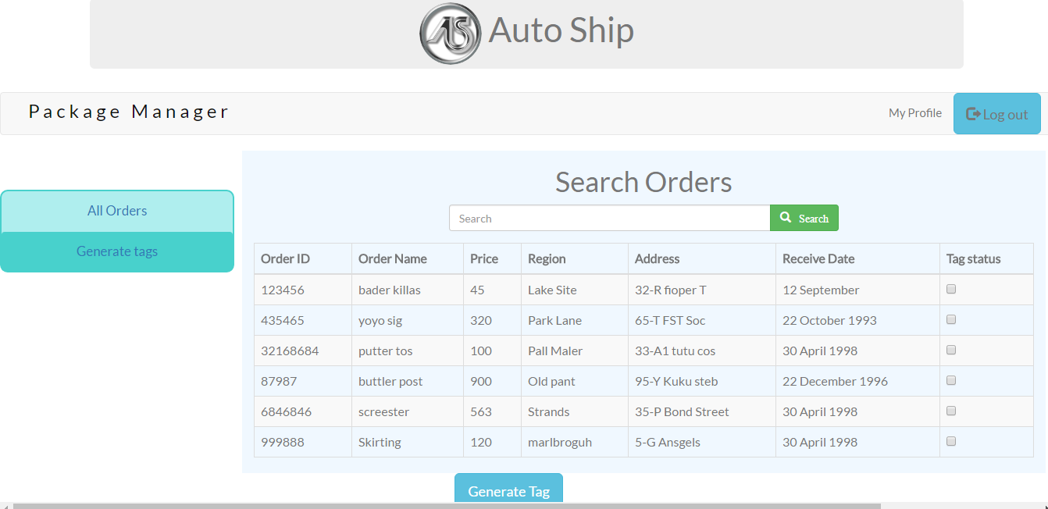
Generate Tags: Error
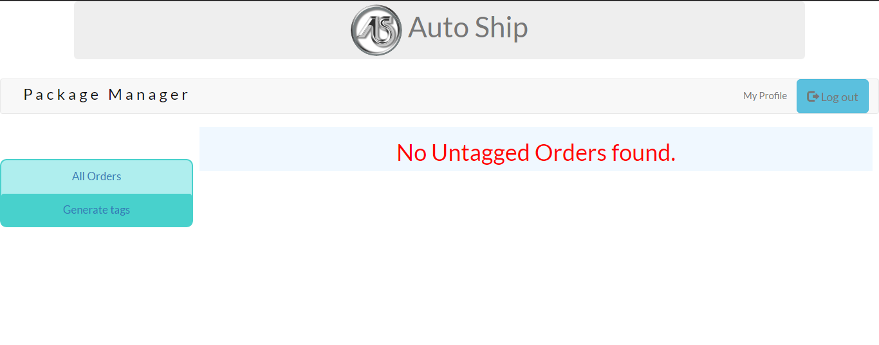

All Orders:

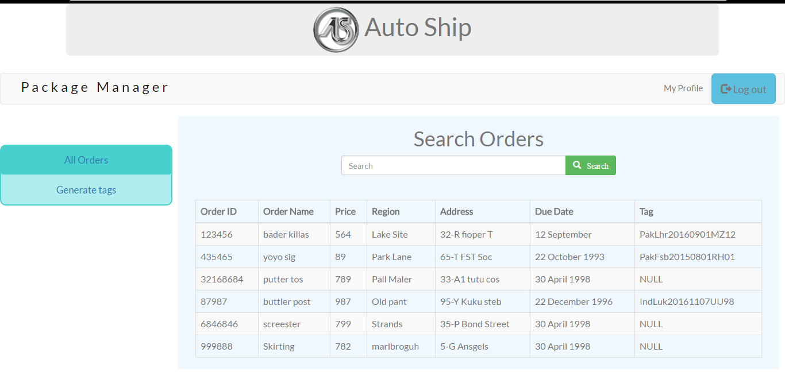

Shipment Manager
All Orders:
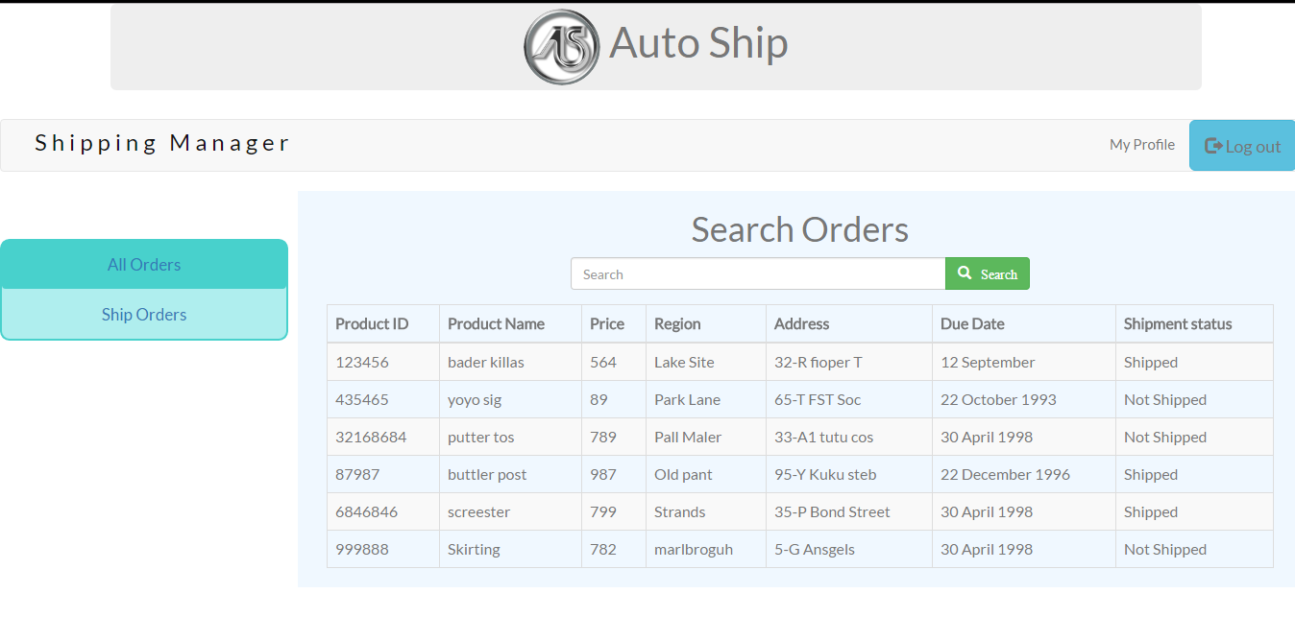

Ship Orders:
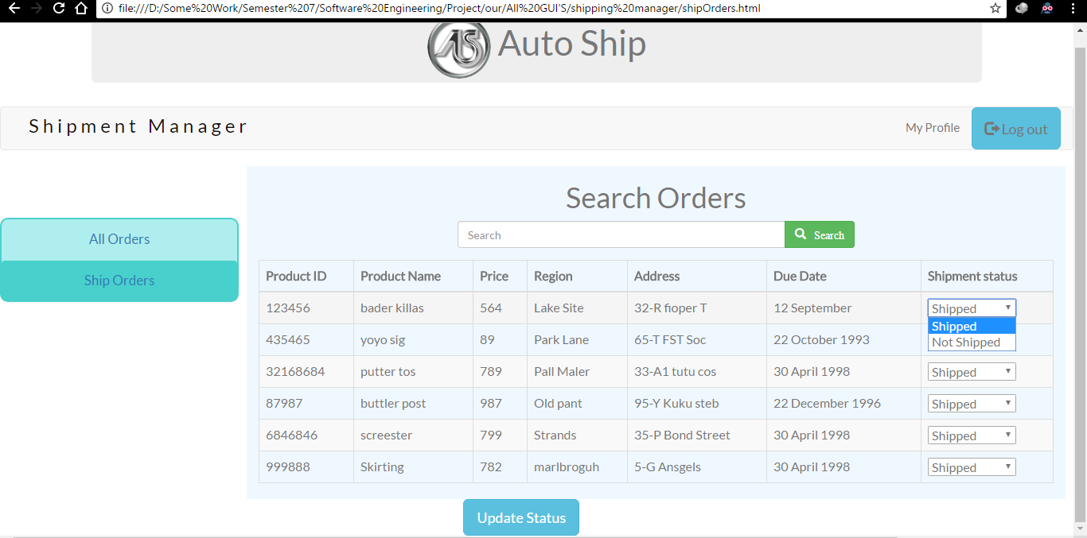

Appendix E: Test Cases
< Fill out the following template for each test case.>

Identifier | TC-1
Priority | <Choose one from {High, Medium, Low}>
Related requirements(s) | <Include use-case identifier(s) for functional requirement(s) and SRS section/sub-section number(s) for other requirement(s).>
Short description | …
Pre-condition(s) | …
Input data | …
Detailed steps | …
Expected result(s) | …
Post-condition(s) | …
Table 1: TC-1
Appendix F: IV & V Report
Appendix F: IV & V Report
IV & V Resource

Taimur Zahid 13L-4191
Name Roll # Signature

S# | Defect Description | Origin Stage | Status | Fix Time
 |  |  |  | Hours | Minutes
1 | The Date Attribute has ambiguous meaning in the "All Orders" page. Can be interpreted as Date of Delivery or Date of Entry. | Graphical User Interface of "All Orders" in the Category "Delivery Person". | open
2 | The Date Attribute has ambiguous meaning in the "Show Route" page. Can be interpreted as Date of Delivery or Date of Entry. | Graphical User Interface of "Show Route" in the Category "Delivery Person". | Open
3 | The Date Attribute has ambiguous meaning in the "Import Orders" page. Can be interpreted as Production Date or Date of Entry. | Graphical User Interface of "Import Orders" in the Category "Manager". | Open
4 | The Date Attribute has ambiguous meaning in the "All Orders" page. Can be interpreted as Production Date or Date of Entry. | Graphical User Interface of "All Orders" in the Category "Manager". | Open
5 | The Date Attribute has ambiguous meaning in the "Generate Tags" page. Can be interpreted as Production Date or Date of Entry. | Graphical User Interface of "Generate Tags" in the Category "Package Manager". | Open
6 | The Tag Status Attribute has ambiguous meaning in the "Generate Tags" page. No meaning associated with checking or unchecking the check boxes. | Graphical User Interface of "Generate Tags" in the Category "Package Manager". | Open
7 | The Date Attribute has ambiguous meaning in the "All Orders" page. Can be interpreted as Production Date or Date of Entry. | Graphical User Interface of "All Orders" in the Category "Package Manager". | Open
8 | The Date Attribute has ambiguous meaning in the "All Orders" page. Can be interpreted as Production Date or Date of Shipment or Date of Entry. | Graphical User Interface of "All Orders" in the Category "Shipping Manager". | Open
9 | The Use case diagram wasn't enclosed in a retangular box to show system boundaries. Also, the correct syntax wasn't followed to draw the use case diagram. | Use Case Diagram | Fixed | 1 | 30
10 | The name of the use case diagram was not placed in the center nor the format was according to the convention/standard. | Use Case Diagram | Open
11 | The Delivery Person has no Data Flow specifying the Delivered Products in the All Orders Section. | Level 0 DFD | Open
12 | The Package Manager has no Data Flow to receive Tagged Products. | Level 0 DFD | Fixed | -- | --
13 | Admin has no incoming Data Flow for All Orders. | Level 0 DFD | Fixed | -- | --
14 | Admin has no incoming Data Flow for All Employees. | Level 0 DFD | Open
15 | The Delivery person has no Data Flow specifying the Products Not Delivered in the All Orders Section. | Level 0 DFD | Fixed | -- | --
16 | The Delivery person has no Data Flow specifying the Orders Selection Option in the Show Route Section. | Level 0 DFD | Fixed | -- | --
17 | The Delivery person has no Data Flow to receice Orders. | Level 0 DFD | Fixed | -- | --
18 | The option to create account/add account relation between the Admin Table and the Accounts Table is missing. There should be an option to view and to add account. | ER Diagram | Fixed | -- | 45
19 | Order Status Table must have a relation with the Orders Table because statuses are associated with their respected orders. | ER Diagram | Fixed | -- | 45
20 | Shipping Manager has the ability to update Orders' Statuses according to the ER Diagram. But According to the GUI, this is not the case. | ER Diagram and  Shipping Manager GUI. | Fixed | -- | 45
21 | No tables or any association between tables indicate Generation and Assignment of Tags. | ER Diagram | Fixed | -- | 45
22 | No data types allowed in Analysis Level Class Diagram | Class Diagram | Fixed | -- | --
23 | No Funtion Parameters allowed in Analysis Level Class Diagram | Class Diagram | Open
24 | Getter and Setter Functions are not allowed in Analysis Level Class Diagram | Order Table in Class Diagram | Fixed | -- | --
25 | No Attributes, Primary keys, and Foreign Keys in the Relations. | ER Diagram | Open

Table 2: List of non-trivial defects

Appendix G: Risk Report

Project Risks

Risk Description | Impact  (1 – 10) | Probability  (0 – 1) | Risk  Exposure | Weeks Active | Mitigation Strategy
Conflict may arise between team members individual work. | 8 | 0.4 | 3.2 | 11 | Group discussions to resolve confusions.
Members may not available for Group meetings on decided time or place | 5 | 0.6 | 3.0 | 11 | Skype and emails are used.
Client may not available for meeting at decided time. | 4 | 0-7 | 2.8 | 11 | Contacted via email and phone.
Loss of data (e-g hard disks corrupted) including project development files, SRS, proposal and other files. | 10 | 0.2 | 2.0 | 11 | Github (online repository) is used.
Team members may not available for work. | 2 | 0.5 | 1.0 | 11 | Workload divided among other members.
Appendix H: Activity Timesheet

Activity | Time
Activity | Hours | Minutes
Requirements Engineering | 3 | 30
Analysis and Design | 2 | 0
Implementation | 168 | 0
Testing | 60 | 25
Deployment | 2 | 0
Project Management | 15 | 0
IV & V | 7 | 30

Project Manager

Muhammad Zunair 13L-5932
Name Roll # Signature

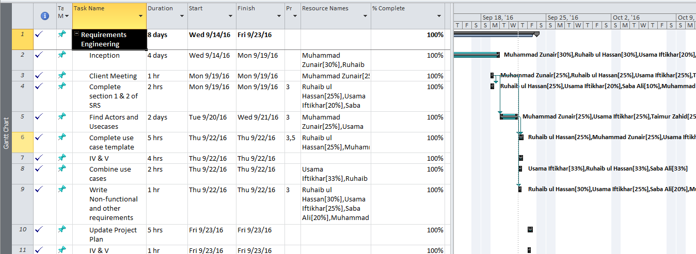
Appendix I: Updated Project Plan
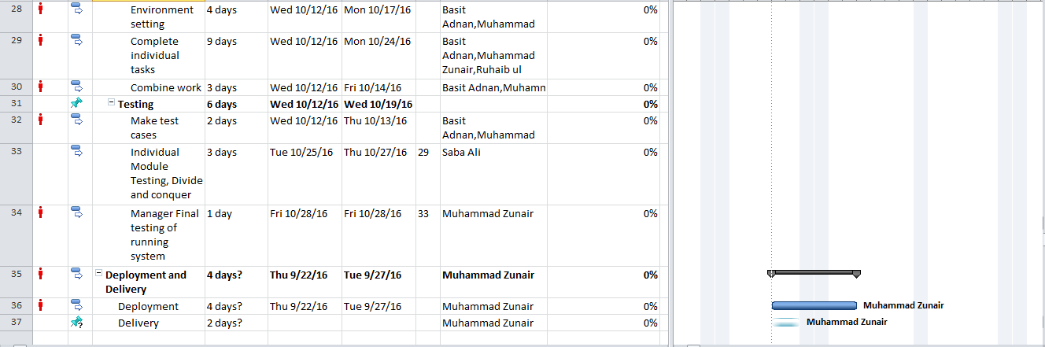
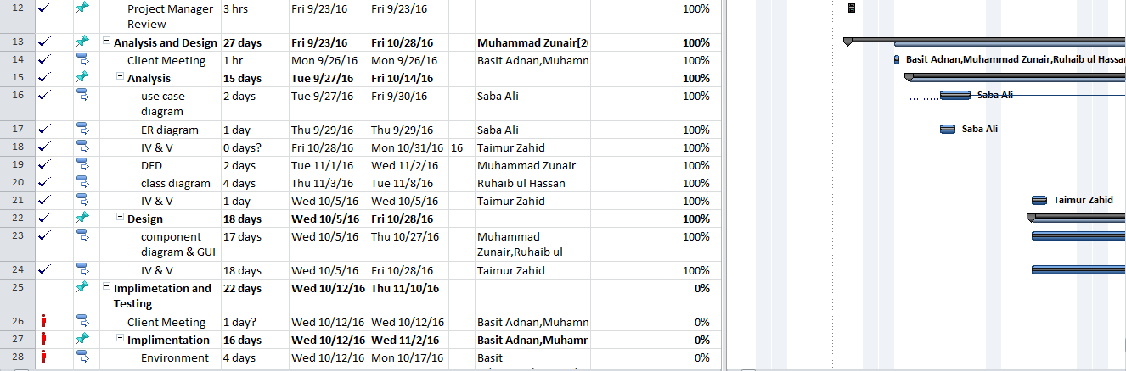

Risks should be sorted in descending order of risk exposure.
Risk Exposure = Risk Impact x Risk Probability

